BSC – HGP – Project Go

UI Design Document & Report

# Division of Work

Student Name1: Matthieu Desrues Student Number1: 3077683

Student Name2: Cleophee Itier Student Number2: 3076679

Please complete the sections below with regard to the estimate of the division of work between the two partners

If the work was split in the range of 45% to 55% per partner, then that is fine and simply say “Work was evenly divided”. If this was not the case, then state with a summary sentence. This is the important statement of this file.

Division of work: work was evenly divided, and working in peer programming to start the project and the different aspect of the system design and game logic. ______________________________________________________________________

## Code repository log (if applicable)

Paste here

## Percentage of work completed by each partner on each class / task

Some areas require more work than others so this is only for reference. An average of these values will not be calculated.

|  |  |  |
| --- | --- | --- |
| **Filename / Task** | **Student Name 1** | **Student Name 2** |
| GoBoard | 70% | 30% |
| Filename 2 | 40% | 65% |
| System design | Work evenly divided |  |
| Git hub repository | Work evenly divided |  |
| Learning rules of draughts | Work evenly divided |  |
| Documentation | 25% | 75% |

# UI Design

**Student Names:** Matthieu Desrues, Cleophee Itier

The ui design was realized inside the boxes to share the screenshots and the elements working and not working.

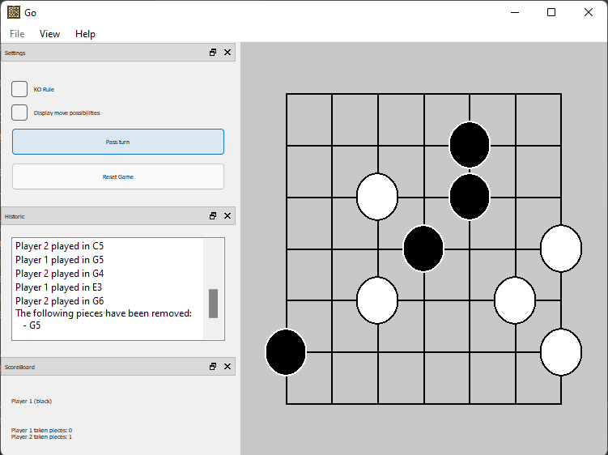All code should be testable where possible and error message should be displayed to show where code has failed.

|  |
| --- |
| **Task 1 (1 image with description + what is working/not working)** |
| When the game is launched a 7 by 7 board is being displayed.   * Location: The board of the game is located at the center because it is the most important part of the design * Colour: There is no specific colour to the design * Size: It is at the center of the application. * Style: It is a plain style. |

|  |
| --- |
| **Task 2 (6 images of working Menus/buttons/Labels including description + what is working/not working)** |
| Menus to access how to play      Pass button (e)  Reset Button (f)  Player turn (d)  Number of pieces taken by player (b)  Show how to play (a)  Here are the different menu/labels/button in the game:   * Location: Every menu are located at the top in the help section to be clear and respect the continuity of the option available. The menu are located at the top of the application. The labels and button are located by default at the left * Colour: There is no specific colour to the design * Size: The menu, labels and button are average but visible to the user. * Style: It is a simple style.   In this task the reset button wasn’t implemented. |

|  |
| --- |
| **Task 3 (2 images + what is working/not working)** |
| Here the placement one piece:   * In this task it is possible to set one piece in the board using a mouse click |

|  |
| --- |
| **Task 4 (2 images + what is working/not working)** |
| Here the placement according to the suicide rule:   * It is not possible to set a piece in the middle of the 4 white stone |

|  |
| --- |
| **Task 5 (2 images + what is working/not working)** |
| No implementation of the KO rule |

|  |
| --- |
| **Task 6 (2 images + what is working/not working)** |
| It is possible to remove one stone at the time and the user has the piece that has been taken displayed. |

|  |
| --- |
| **Task 7 (2 images + what is working/not working)** |
| It is possible to remove multiple piece at the same time and the user has the different stone that has been taken displayed. |

|  |
| --- |
| **Task 8 (2 images + what is working/not working)** |
| It is possible to end the game by pressing the pass button twice |

|  |
| --- |
| **Task 9 (2 images + what is working/not working)** |
| No additional features |